Parth Shukla
Lab 2
190905104

1)
#include "mpi.h"
#include <stdio.h>
#include <stdlib.h>
#include <string.h>
#include <unistd.h>
int main(int argc, char *argv[])
{
int size, rank;
MPI_Status status;
MPI_Init(&argc, &argv);
MPI_Comm_size(MPI_COMM_WORLD, &size);
MPI_Comm_rank(MPI_COMM_WORLD, &rank);
char word[5], y[5];
int len = 5 * sizeof(char);
if (rank == 0)
{
scanf("%s", word);
MPI_Ssend(word, len, MPI_CHAR, 1, 101, MPI_COMM_WORLD);
printf("Process %d sent: %s\n", rank, word);
MPI_Recv(word, len, MPI_CHAR, 1, 102, MPI_COMM_WORLD,
&status);
printf("Process %d received: %s\n", rank, word);
}
else
{
MPI_Recv(y, len, MPI_CHAR, 0, 101, MPI_COMM_WORLD,
&status);
printf("Process %d received: %s\n", rank, y);
for (int i = 0; i < strlen(y); i++)
{
if (y[i] >= 'A' && y[i] <= 'Z')
y[i] += 32;
else if (y[i] >= 'a' && y[i] <= 'z')
y[i] -= 32;
}
sleep(1);
MPI_Ssend(y, len, MPI_CHAR, 0, 102, MPI_COMM_WORLD);
printf("Process %d sent: %s\n", rank, y);
}
MPI_Finalize();
}

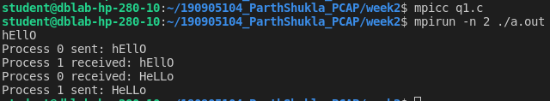
2)

#include <mpi.h>
#include <stdio.h>
#include <stdlib.h>
#define SIZE sizeof(int)

int main(int argc, char *argv[])
{
int size, rank;
MPI_Status status;
MPI_Init(&argc, &argv);
MPI_Comm_size(MPI_COMM_WORLD, &size);
MPI_Comm_rank(MPI_COMM_WORLD, &rank);
int *number = (int *)malloc(SIZE);
int i;
if (rank == 0)
{
*number = 5;
for (i = 1; i < size; ++i)
{
printf("%d. Sent to %d: %d\n", rank, i, *number);
// Send to the process with ID = i
MPI_Send(number, SIZE, MPI_INT, i, 100 + i,
MPI_COMM_WORLD);
}
}
else
{
// Revc from the process with ID = 0
MPI_Recv(number, SIZE, MPI_INT, 0, 100 + rank, MPI_COMM_WORLD,
&status);
printf("%d. Recv: %d\n", rank, *number);
}
MPI_Finalize();
}

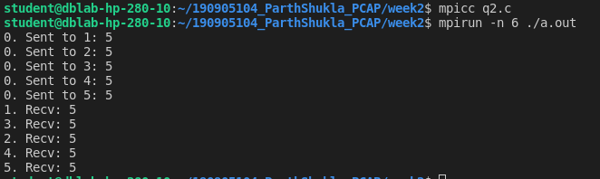
3)

#include "mpi/mpi.h"
#include <stdio.h>
#define comm MPI_COMM_WORLD

int main(){
int rank,size;
int arr[10],num;
MPI_Status status;
MPI_Init(NULL,NULL);
MPI_Comm_rank(comm,&rank);
MPI_Comm_size(comm,&size);
int buff[100];
int buffsize=100;

if(rank==0){
printf("enter an array of %d numbers",size-1);
for(int i=1;i<size;i++){
scanf("%d",&arr[i]);
}
MPI_Buffer_attach(buff,buffsize);
for(int i=1;i<size;i++){
MPI_Bsend(&arr[i],1,MPI_INT,i,i,comm);
}
MPI_Buffer_detach(&buff,&buffsize);
}
else{
MPI_Recv(&num,1,MPI_INT,0,rank,comm,&status);
if(rank%2==0){
printf("in rank %d and number received is %d\neven rank - squared number is %d\n\n",rank,num,num*num);

}
else{
printf("in rank %d and number received is %d\nodd rank - cubed number is %d\n\n",rank,num,num*num*num);

}

}
MPI_Finalize();
return 0;
}

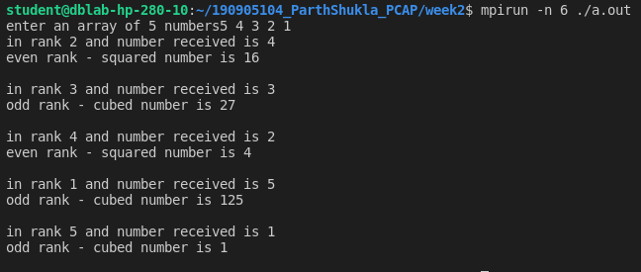

4)
#include <stdio.h>
#include <stdlib.h>
#include <mpi.h>
#include <string.h>
int main(int argc, char *argv[])
{
int rank, size, num;
MPI_Init(&argc, &argv);
MPI_Comm_rank(MPI_COMM_WORLD, &rank);
MPI_Comm_size(MPI_COMM_WORLD, &size);
if (rank == 0)
{
printf("\nEnter a number -- ");
scanf("%d", &num);
printf("\nProcess 0 -- ");
printf("\nSending integer %d\n", num);
MPI_Send(&num, 1, MPI_INT, 1, 0, MPI_COMM_WORLD);
MPI_Recv(&num, 1, MPI_INT, size - 1, 0, MPI_COMM_WORLD, MPI_STATUS_IGNORE);
printf("\nProcess 0 -- \nReceived int %d\n", num);
}
else
{
MPI_Recv(&num, 1, MPI_INT, rank - 1, 0, MPI_COMM_WORLD, MPI_STATUS_IGNORE);
printf("\nProcess %d -- ", rank);
printf("\nReceived integer %d", num);
num++;
printf("\nSending integer %d\n", num);
MPI_Send(&num, 1, MPI_INT, (rank + 1) % size, 0, MPI_COMM_WORLD);
}
MPI_Finalize();
return 0;
}

